**Auto Insurance Fraud**

**Problem Definition**

**Aim of the project**

The aim of the project is to find the Auto Insurance Fraud Reported. Insurance fraud is a huge problem in the industry. It's difficult to identify fraud claims. Machine Learning is in a unique position to help the Auto Insurance industry with this problem. As per industry specific identifying a fraudulent report of auto insurance claim is a very high task from its customer data.

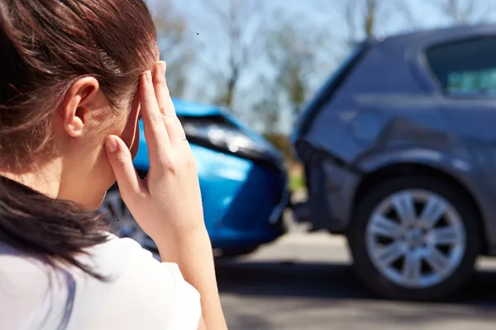

**Why Auto Insurance Fraud Detection:** Insurance fraud occurs when a customer attempts to earn profit by exploiting the terms and conditions of the insurance agreement. The Auto Insurance fraud takes place when the vehicle collision occurs or vehicle theft. These days investigating a single case being very time consuming also it becomes very complex to identifying a whole number of fraudulent. **To identifying fraudulent through dataset will be very grateful to the industry specific**.

**Model Aims:** The aim of the model to detect the Automobile Insurance customer’s fraud reported or not. The model built to predict the fraud reported will be aiming to obtain the highest **Accuracy score**.

**Accuracy** simply measures how often the classifier correctly predicts. We can define accuracy as the ratio of the number of correct predictions and the total number of predictions.

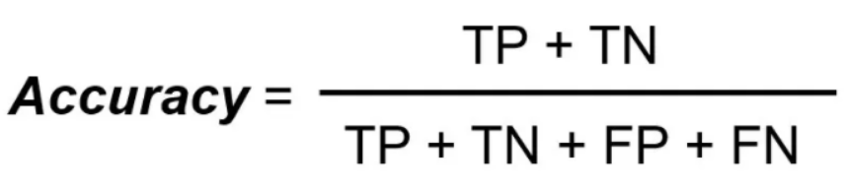

The model will also aim towards obtaining the **highest ROC AUC score, Precision score and Recall**.

**Precision** for a label is defined as the number of true positives divided by the number of predicted positives.

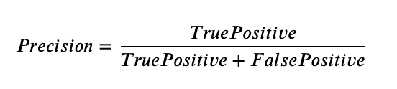

**Recall (Sensitivity)** for a label is defined as the number of true positives divided by the total number of actual positives.

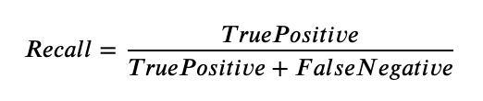

**AUC-ROC** — The Receiver Operator Characteristic (ROC) is a probability curve that plots the TPR(True Positive Rate) against the FPR(False Positive Rate) at various threshold values and separates the ‘signal’ from the ‘noise’.

**Overview of the dataset**

The dataset is obtained from: <https://github.com/dsrscientist/Data-Science-ML-Capstone-Projects/blob/master/Automobile_insurance_fraud.csv>

* Dataset having 10000 rows and 40 columns.
* Dataset having 19 numerical and 21 object type columns.

**Features of the dataset**

|  |  |
| --- | --- |
| **'months_as_customer'** | Number of months of the customer retain |
| **'age’** | Age of the customer |
| **'policy_number'** | Identity of the customer |
| **'policy_bind_date'** | Date in policy coverage get into place |
| **'policy_state'** | Policy State location details |
| **'policy_deductable'** | Deductible amount of the policy |
| **'policy_annual_premium'** | Annual premium amount of the policy |
| **'umbrella_limit'** | Umbrella limit amount of the policy |
| **'insured_zip'** | Zip code of the customers |
| **'insured_sex'** | Gender |
| **'insured_education_level'** | Education level of the customers |
| **'insured_occupation'** | Occupation of the customers |
| **'insured_hobbies'** | Hobbies of the customers |
| **'insured_relationship'** | Relationship of the customers |
| **'capital-gains'** | Capital gain of the customers |
| **'capital-loss'** | Capital loss of the customers |
| **'incident_date'** | Incident date of the accident |
| **'incident_type'** | Incident type of the accident |
| **'collision_type'** | Collision type of the accident |
| **'incident_severity'** | Severity of the accident auto mobile |
| **'authorities_contacted'** | Authorities contacted when incident occurred |
| **'incident_state'** | Incident state of the customers |
| **'incident_city'** | Incident city of the customers |
| **'incident_location'** | Incident location of the customers |
| **'incident_hour_of_the_day'** | Hour when the incident occurred |
| **'number_of_vehicles_involved'** | The number of vehicles involved in the accident |
| **'property_damage'** | Property damage during the incident |
| **'bodily_injuries'** | Bodily injuries occurred during the incident |
| **'witnesses'** | Witnesses during the incident |
| **'police_report_available'** | Police report |
| **'total_claim_amount'** | The total amount to be claimed by the customers |
| **'injury_claim'** | The injury claim to be claimed by the customers |
| **'property_claim'** | The property claim to be claimed by the customers |
| **'vehicle_claim'** | The vehicle claim to be claimed by the customers |
| **'auto_make'** | Automobile company of the customers |
| **'auto_model'** | Automobile models of the customers |
| **'auto_year'** | Automobile purchase year |
| **'fraud_reported'** | Fraud reported by the customers |
| **'policy_csl'** | Predetermined limit for the combined total of the Bodily Injury Liability coverage and Property Damage Liability coverage per occurrence or accident |

**Model Building**

**Data Analysis**

**Used Libraries:**

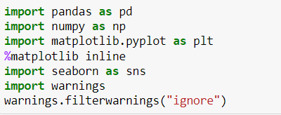

**Importing Dataset**



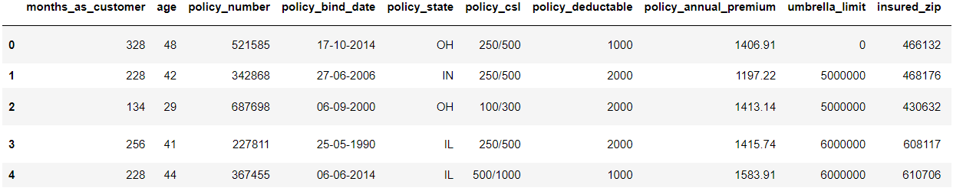

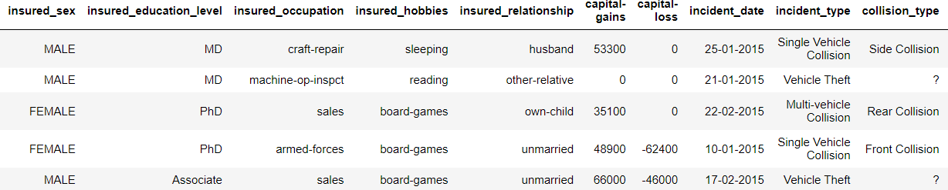

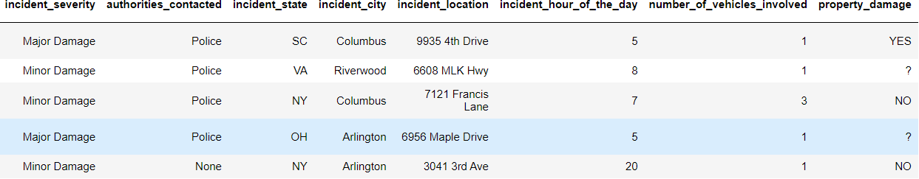

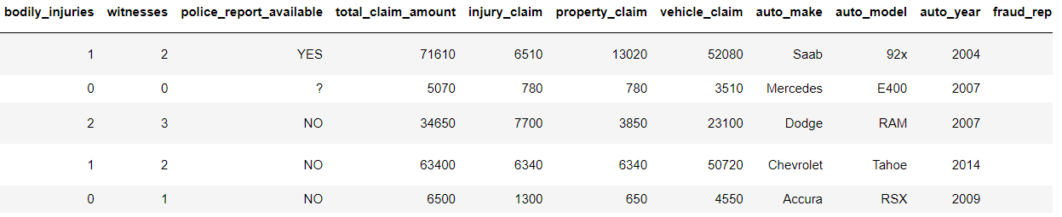

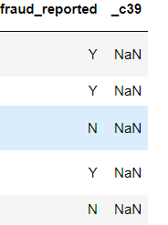

**Checking data types of the dataset**

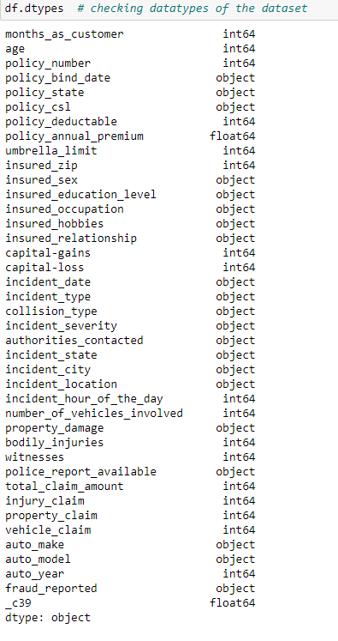

**Observations**:

* From above code we find that 'months_as_customer', 'age', 'policy_number', 'policy_deductable', 'policy_annual_premium', 'umbrella_limit', 'insured_zip',

'capital-gains', 'capital-loss', 'incident_hour_of_the_day',

'number_of_vehicles_involved', 'bodily_injuries', 'witnesses',

'total_claim_amount', 'injury_claim', 'property_claim', 'vehicle_claim',

'auto_year', '_c39' these columns are of numerical types.

* And these are object tpyes 'policy_bind_date', 'policy_state', 'policy_csl', 'insured_sex',

'insured_education_level', 'insured_occupation', 'insured_hobbies',

'insured_relationship', 'incident_date', 'incident_type',

'collision_type', 'incident_severity', 'authorities_contacted',

'incident_state', 'incident_city', 'incident_location',

'property_damage', 'police_report_available', 'auto_make', 'auto_model',

'fraud_reported'.

**Summary of the dataset**:

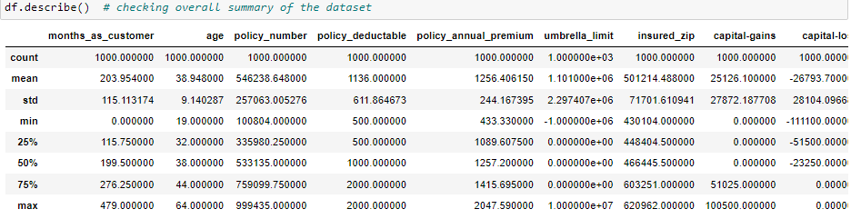

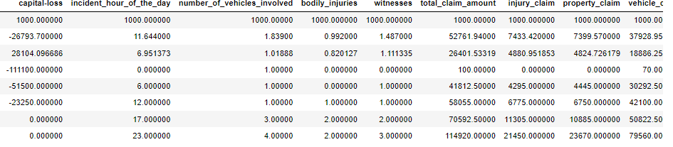

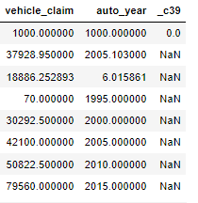

**Checking Summary Visually for Ease in Understandings**

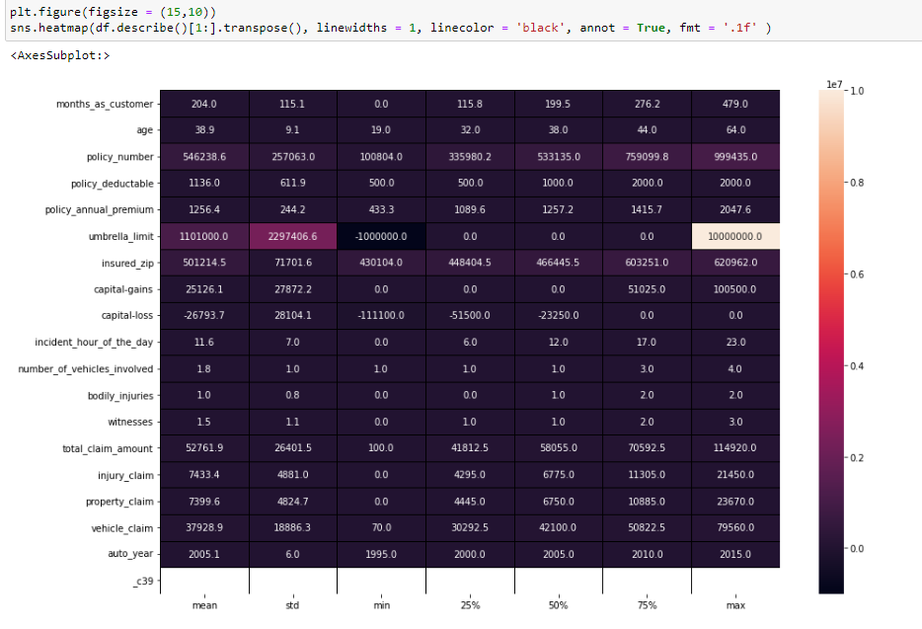

**From above visualization summary we find that:-**

1. Umbrella_limit maximum values are very much higher than its overall dataset hence this column dataset probably having outliers.
2. Total_claim_amount having also very high value of maximum which is more far away then its mean as per above graph hence we can say that some of outliers are in the dataset.

**Quick Summary of the dataset**:

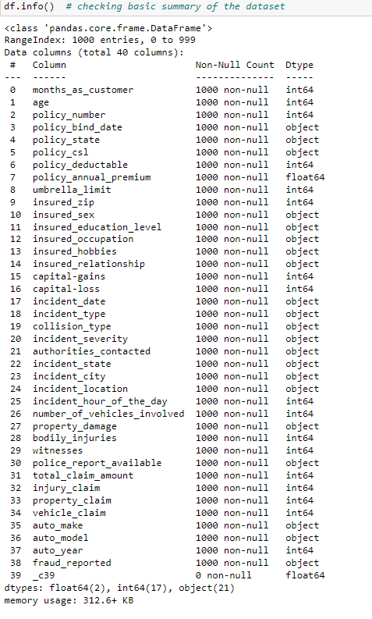

**Checking Target Variable**

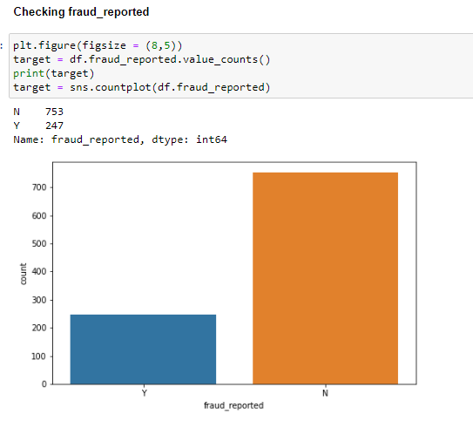

**Observations of the target variable**

* From above fraud_reported output we can see that dataset are in imbalance count hence we need to fix it further for better performance model later.

**Checking Null Values in the dataset**

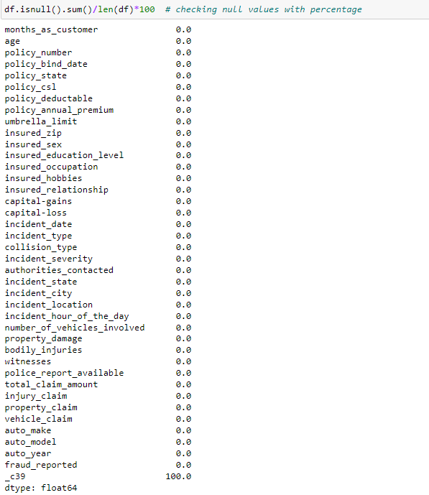

**Checking Null Values of the dataset visually**

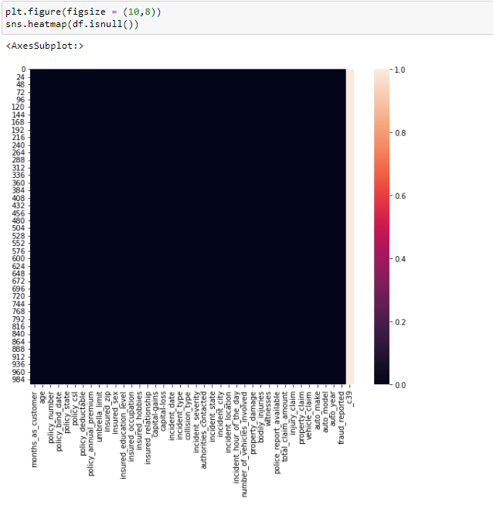

We can see that column _c39 having all rows with NaN values hence we need to drop it.

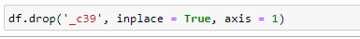 Dropped _c39 from the dataset.

From dataset analysis we find that dataset still having NaN values with ? symbol which means unknown hence we are going to replace with NaN and making assumptions to clean the dataset.

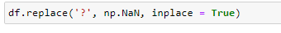

**Code to check NaN values columns**

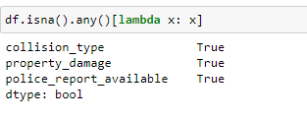

We find that collision_type, property_damage and police_report_available having NaN values.

**Dealing with NaN values by imputation**







We are going to fill NaN values with most frequent values of the dataset as NaN columns are of object types.

**Converting date columns dataset to date time format**



Extracting important details

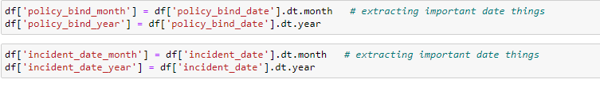

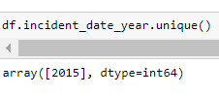

We are going to drop this column because we didn't find any machine learning information in it.

**Dropping Columns which are not liable in model learning**

**We find that policy_number, incident location, insured_zip are the unique values of the location and identification of the customer hence these dataset are liable in prediction hence we need to drop it.**

**We extracted all important details from incident date and policy bind date hence we can drop it.**

df.drop(['policy_number', 'policy_bind_date', 'incident_location', 'incident_date_year','incident_date','insured_zip'], inplace = True, axis = 1)



**Checking Unique value counts**

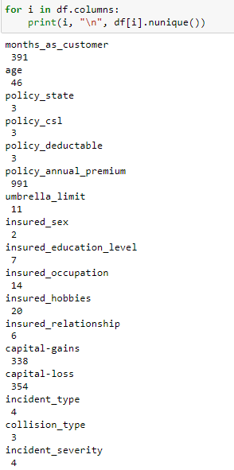

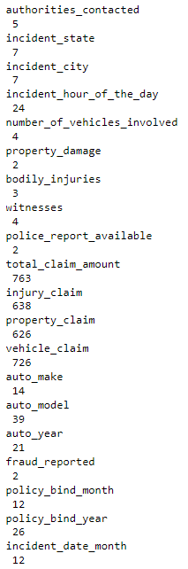

**We find that umbrella limit shows very higher values in dataset, this dataset has unique values in a few amounts hence we can convert it into object data type.**

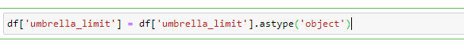

**Dividing columns into object and numerical categories for easy visualization understandings**



**Exploratory Data Analysis Concluding Remarks**

**Bar Plot**

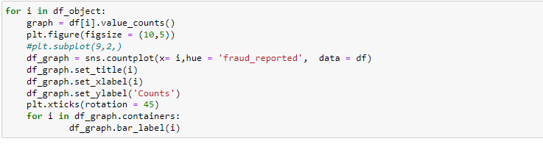

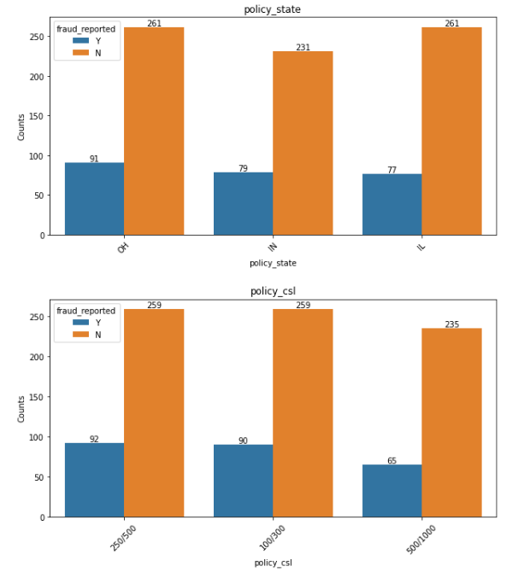

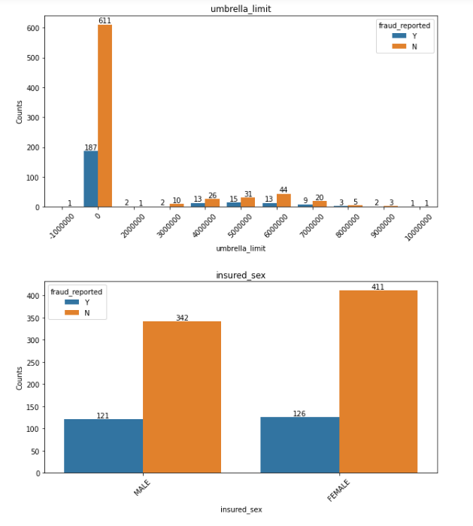

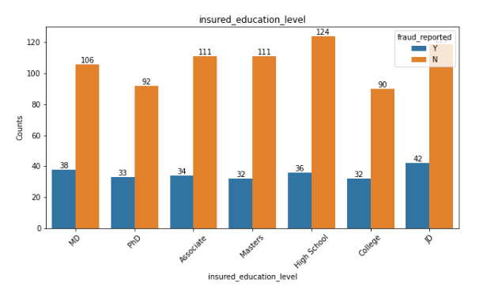

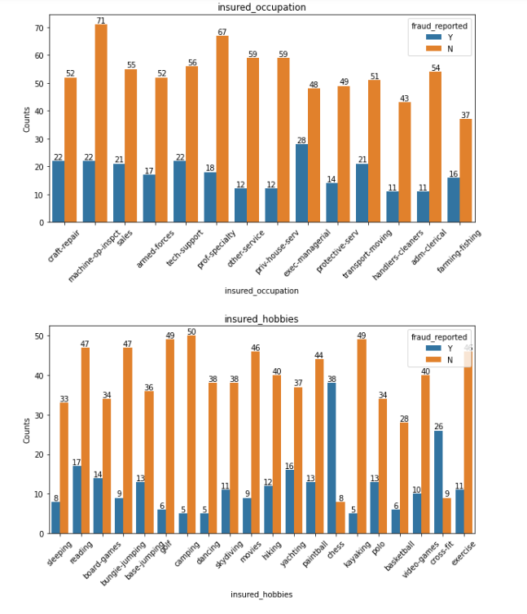

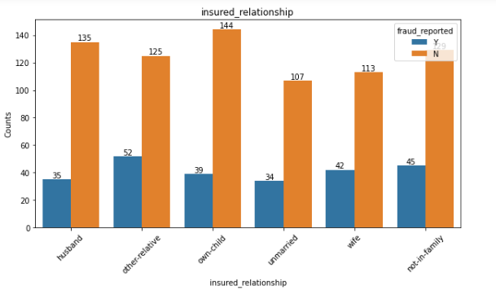

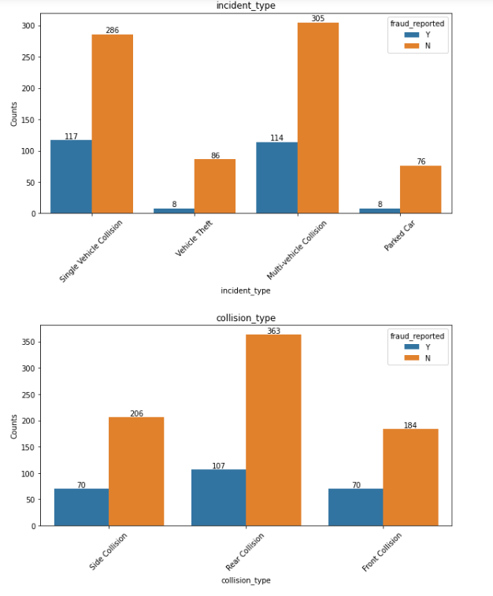

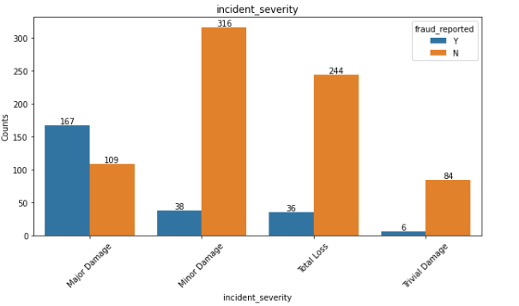

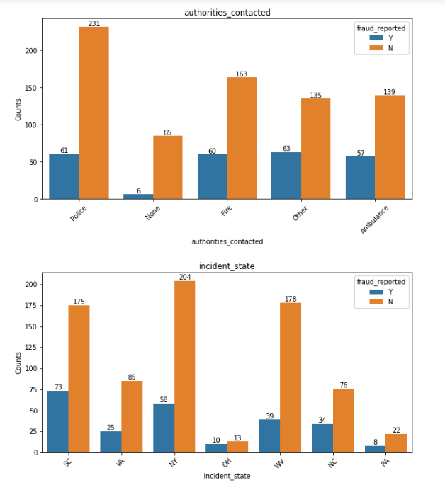

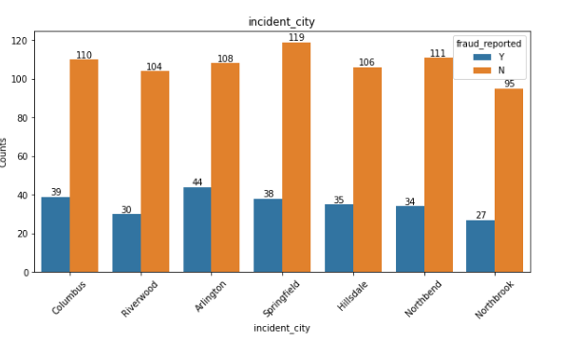

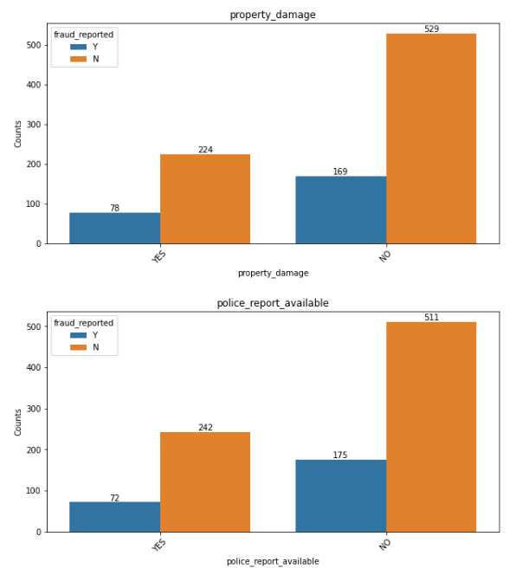

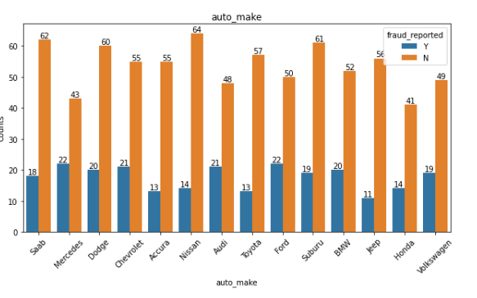

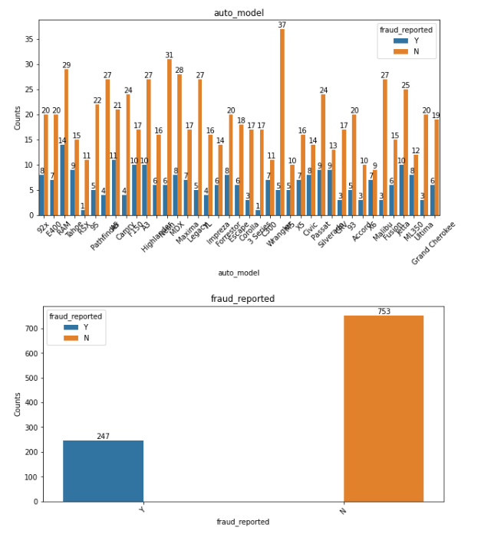

**Observations** :

1. policy_state with OH are morely going to fraud as per dataset.
2. 250/500 policy_csl are going to fraud as per dataset.
3. insured_sex : Female candidates are more fraudster than males as per given dataset.
4. insured_education_level : JD education people are more likely to do fraud as per dataset.
5. insured_occupation : exec-managerial are going to fraud more.
6. insured_hobbies : People with hobby chess are going to fraud more as per dataset.
7. insured_relationship: other-relative relationship are fraud more as per dataset.
8. incident_type: Single Vehicle Collision are going to fraud more.
9. collision_type: Rear Collision are going to fraud more as per dataset.
10. incident_severity: Major Damage severity people going to fraud more as per dataset.
11. authorities_contacted: Most of fraudster contact Other authorities as per dataset.
12. incident_state: Most of the fraudster are of SC state.
13. incident_city: Arlington city having more chances of fraudster.
14. property_damage: No property damage people are going to fraud more as per dataset.
15. police_report_available: No police report people having chances to fraud more as per dataset.
16. auto_make : Mercedes, Ford people are morely to report as fraud as per dataset.
17. auto_model: RAM having more count of fraud as per dataset.

**Pie Chart**

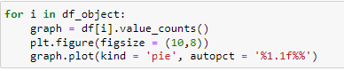

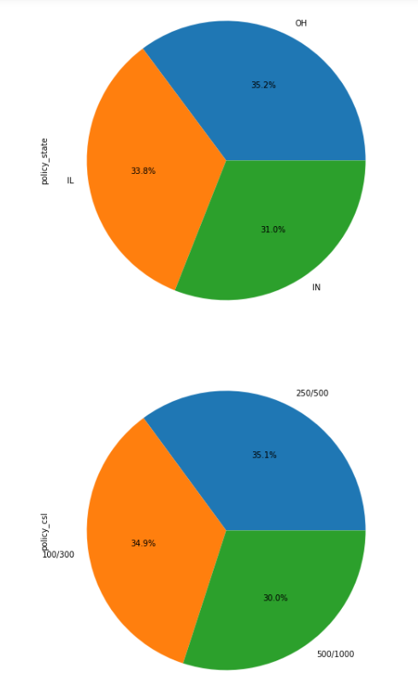

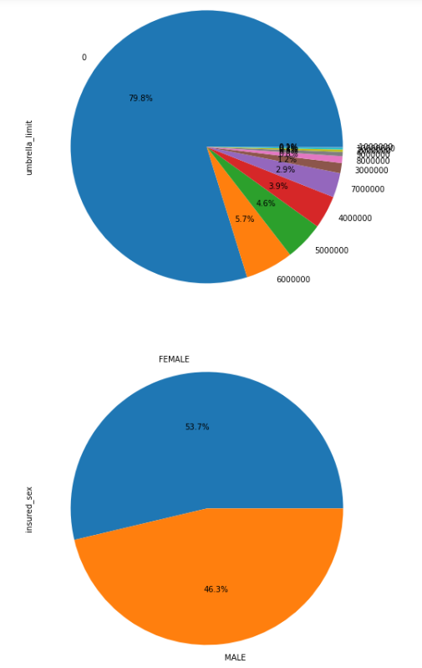

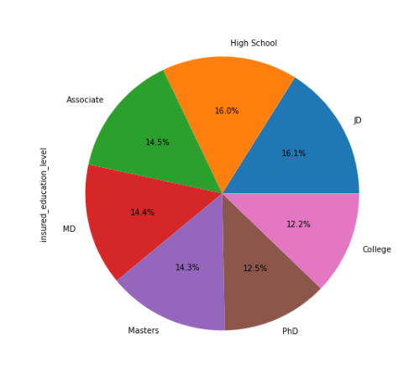

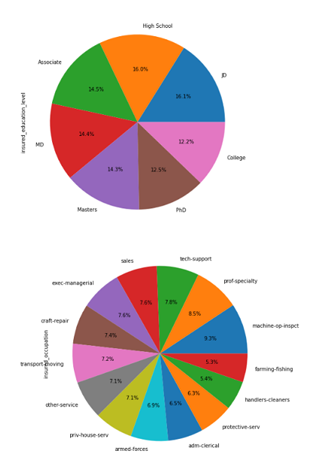

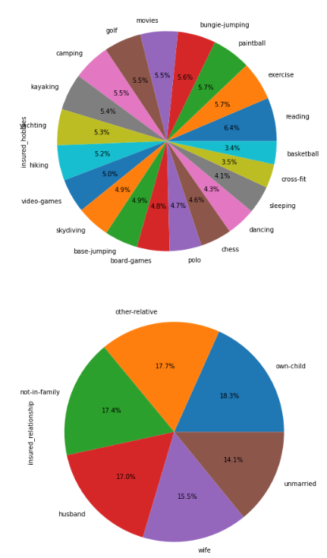

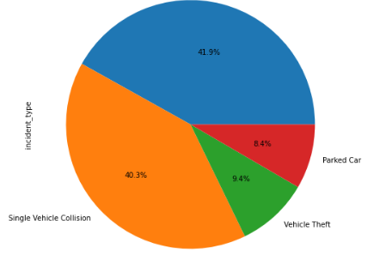

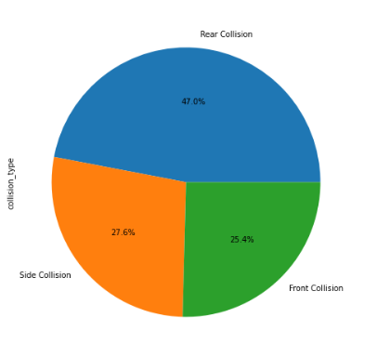

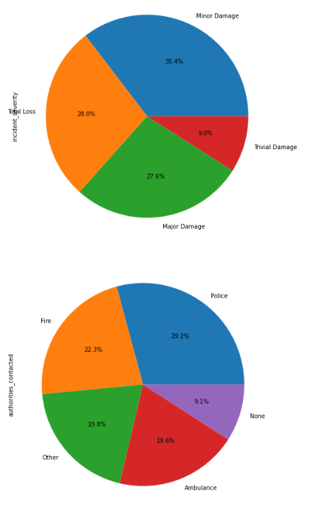

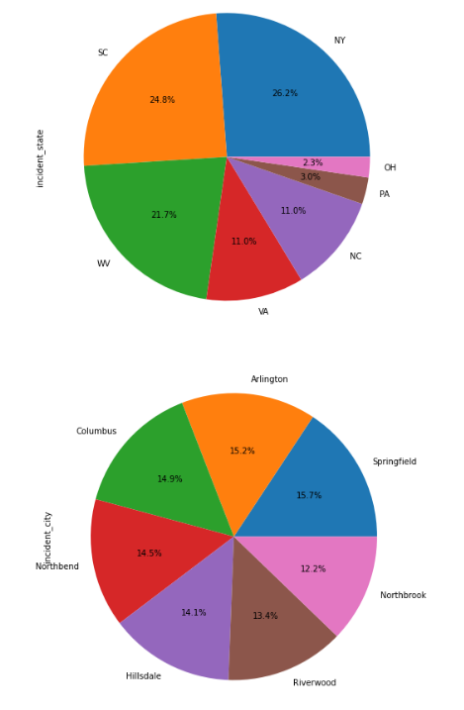

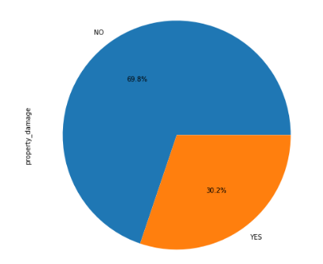

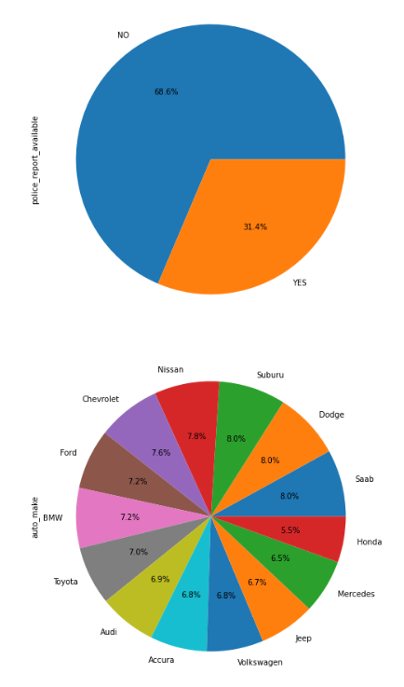

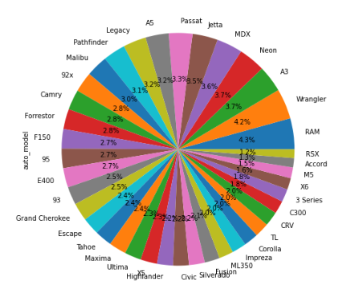

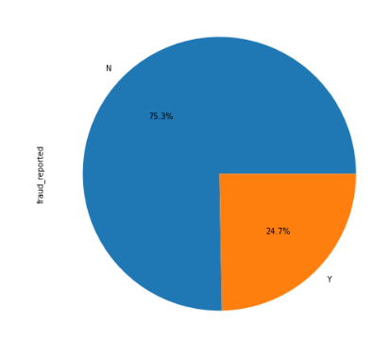

**Observations** we find:

1. policy_state 35.2 percent of the people select OH policy as per dataset.
2. policy_csl: 35.1 percent of the people select OH policy as per dataset.
3. umbrella limit - Most of the people doesn't having umbrella limit only 20.2 percent ratio of people having umbrella limit.
4. insured_sex : Female candidates are more than males as per given dataset.
5. insured_education_level : JD education people are more people rather than others as per dataset.
6. insured_occupation : 8.5 ratio are of prof-specialty procession people which are higher from among all occupation.
7. insured_hobbies : People with hobby reading are more as per dataset.
8. insured_relationship: own child relationship are more as per dataset upto 18.3 ratio.
9. incident_type: Multi Vehicle Collision are higher in ratio.
10. collision_type: Rear Collision are more as per dataset.
11. incident_severity: Minor Damage severity people are more in auto mobiles.
12. authorities_contacted: Most of people contact police as per dataset.
13. incident_state: Most of the people are of SC state as per graph.
14. incident_city: Arlington city having more chances of fraudster as most of the people are of Arlington.
15. property_damage: No property damage are more as per dataset with ratio 69.8.
16. police_report_available: No police report available for 68.6 percent cases as per dataset.
17. auto_make : suburu and Dodge are more in auto make per dataset with ratio of 8 percent.
18. auto_model: RAM having more count of as per dataset with ratio of 4.2%.

**From above all observations we find that Auto_model does not give any informtion about model building because fraudster doesn't show interest in a specific model.**

**Hence we can drop it.**



**Numerical Columns dataset**

Box Plot

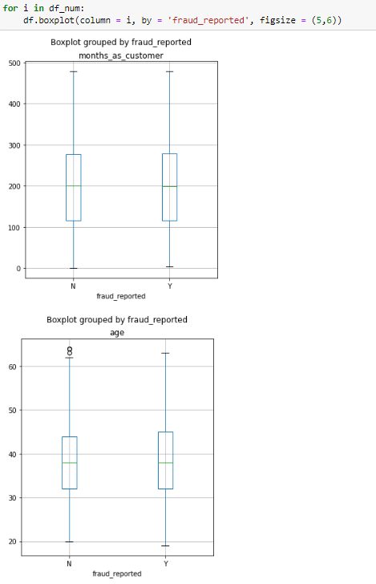

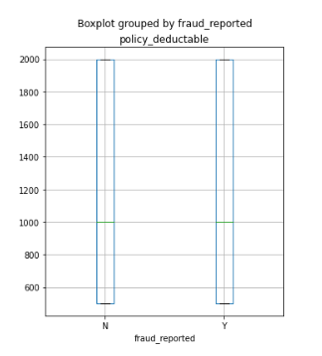

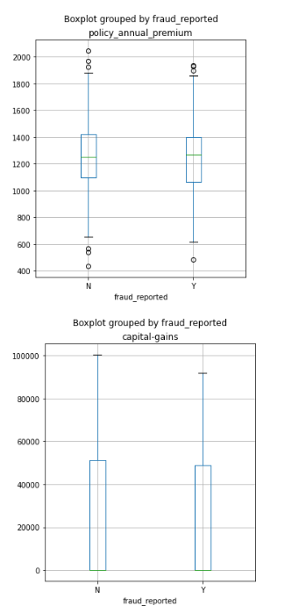

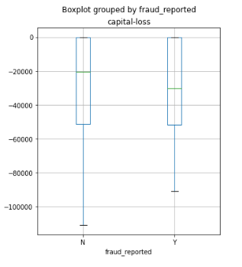

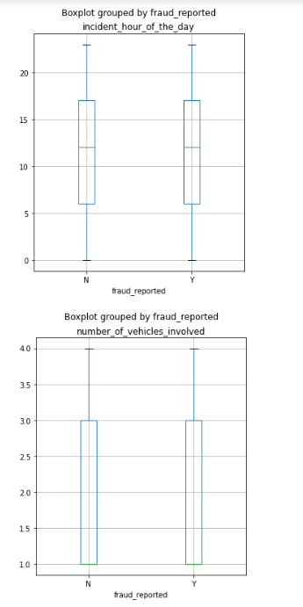

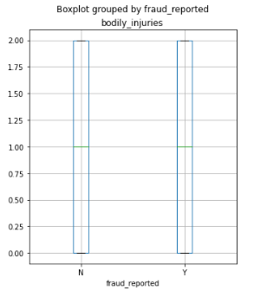

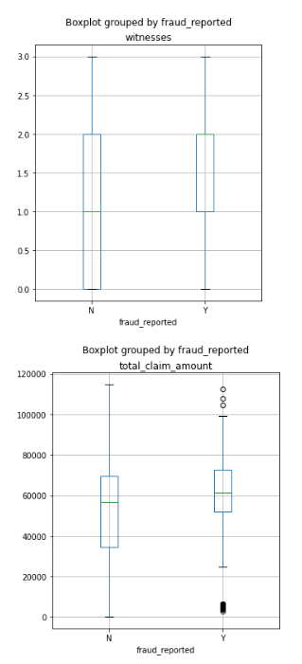

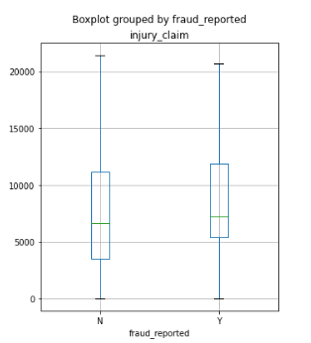

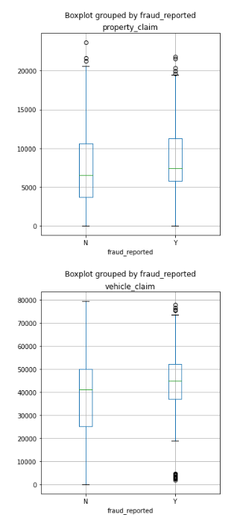

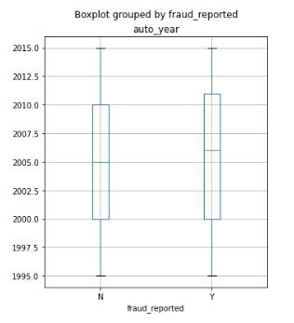

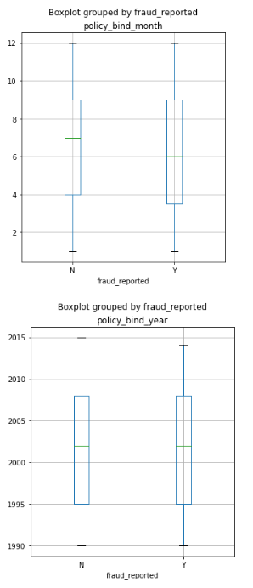

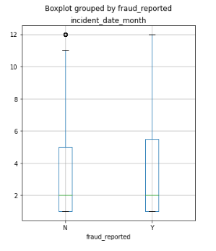

**Observations:-**

1. age: age column dataset having a neglible amount of outliers as per above graph.
2. policy_annual_premimum having outliers in both criteria with fraud reported yes and no.
3. umrella_limit having too much outliers as per above graph.
4. totol _claim_amount having outliers in the dataset of fraud reported as yes.
5. property_claim having outliers in both criteria.
6. vehicle claim having outliers only in the dataset of Y fraud reported.

**Fraud_reported count with respect to incident_data_month**

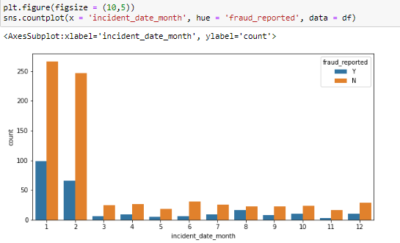

**Observations**: From above graph we find that in the month of January most of the people being reported as fraud.

**Fraud_reported count with respect to incident_hour_of_the_day**

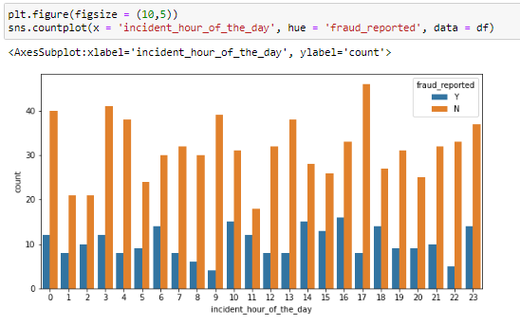

**Observations**: There is not a common pattern to say that that on this hour claim peopled are going to do fraud in future.

**Fraud_reported count with respect to Policy_bind_year**

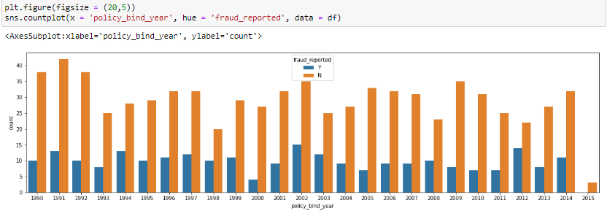

**Observations:** There is not a common pattern to say that that on this hour claim peopled are going to do fraud in future.

**Policy_bind_month counts**

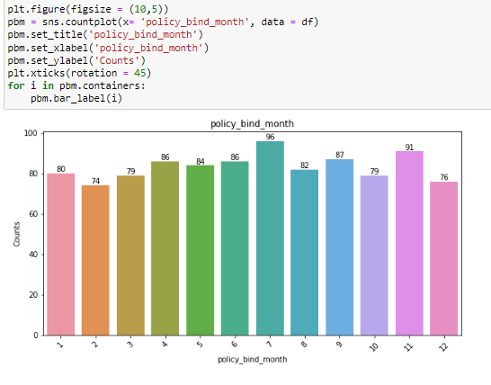

**Observations:** On 7 month of year maximum people bind with a policy as per graph and very low in February.

**Categorical Plot**

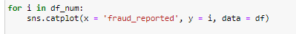

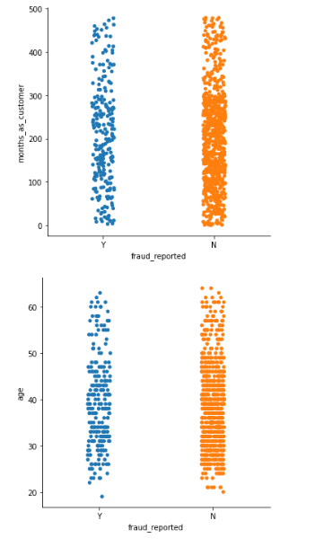 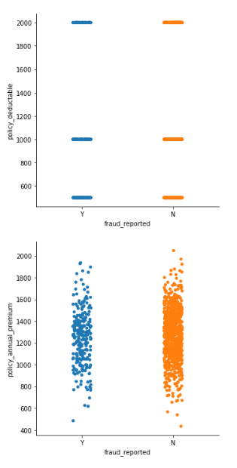

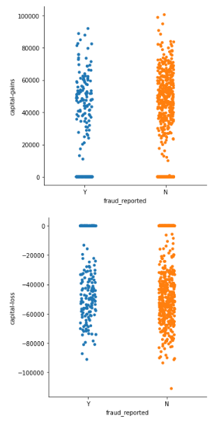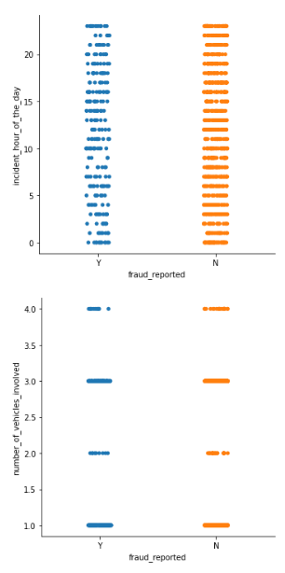

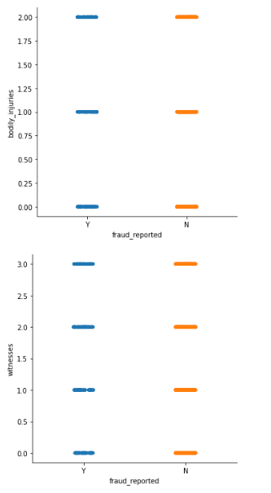 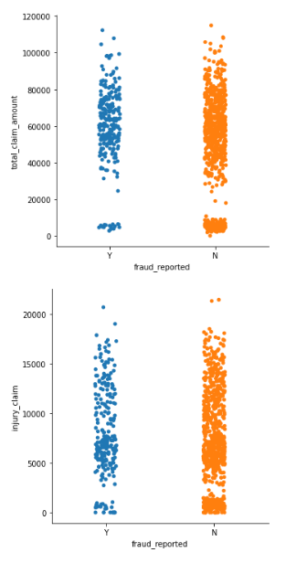

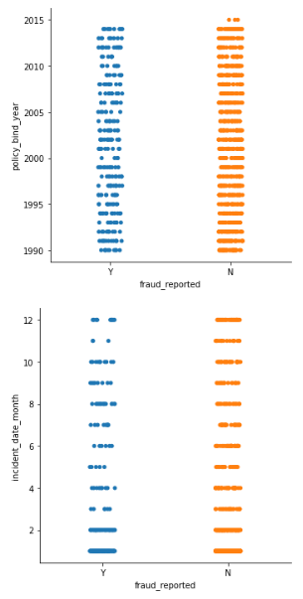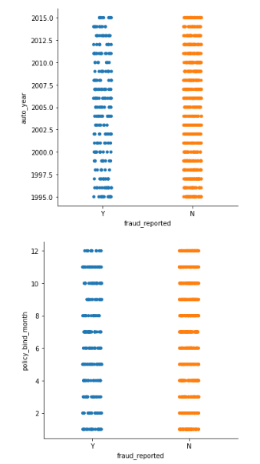

**Observations**: As per above graphs, we find that most of the dataset having fraud_reports N present in higher amounts.

**Bivariate Analysis of Numerical Dataset**

**Code**

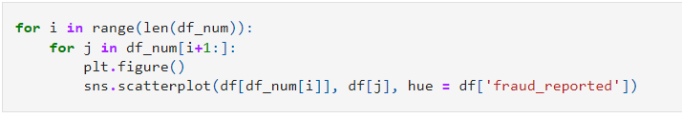

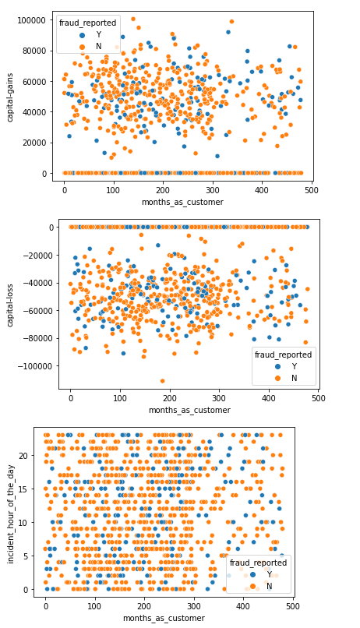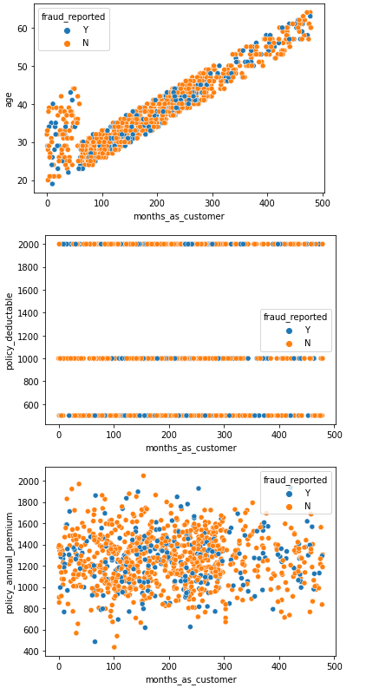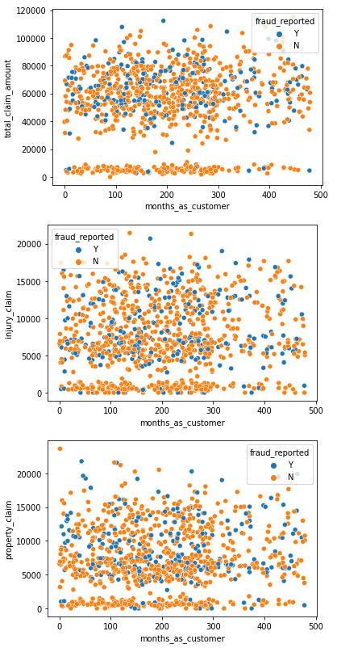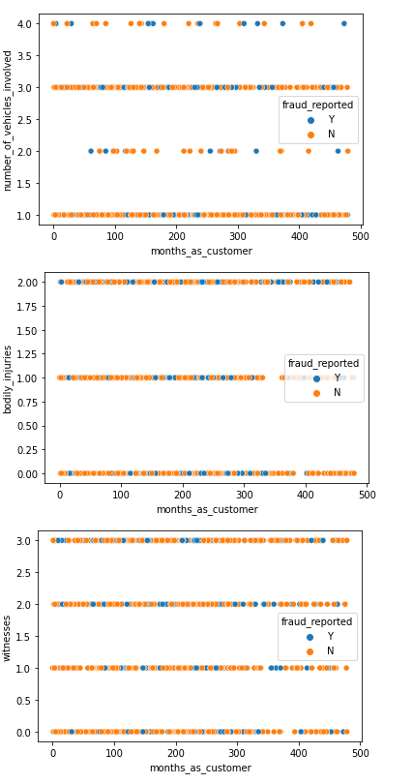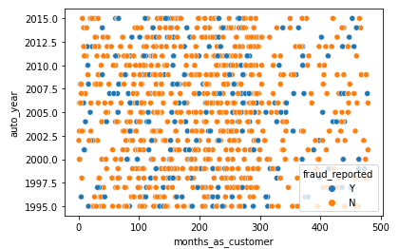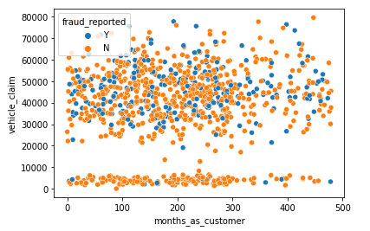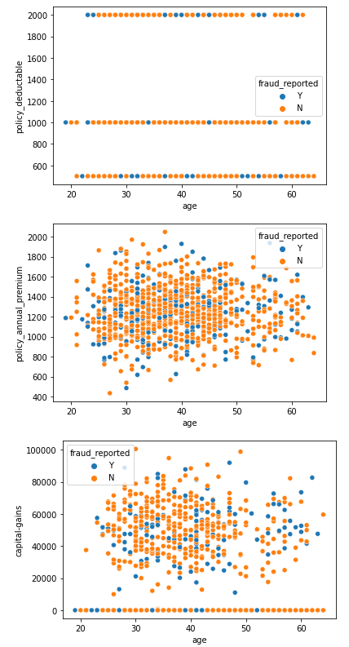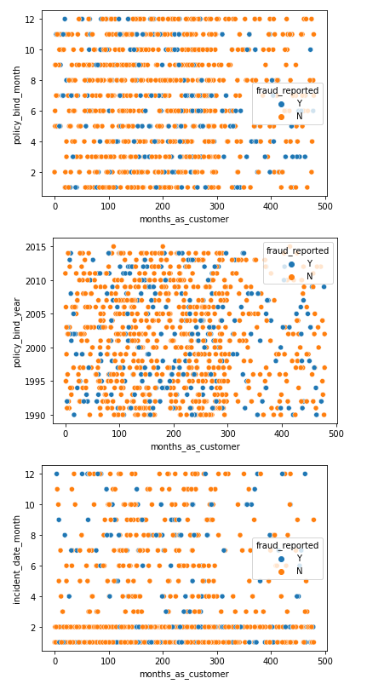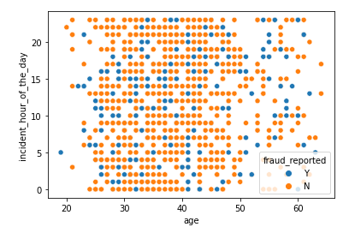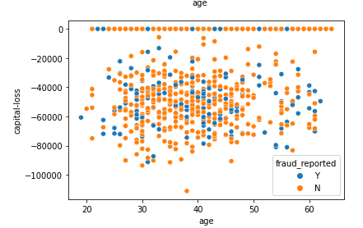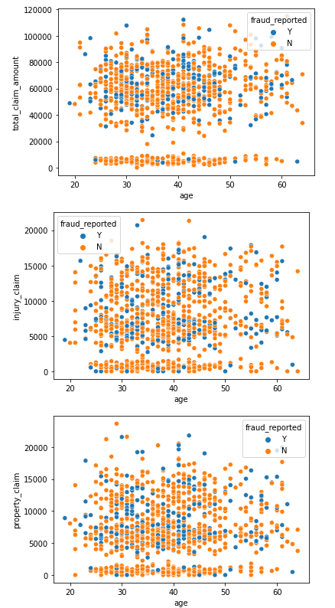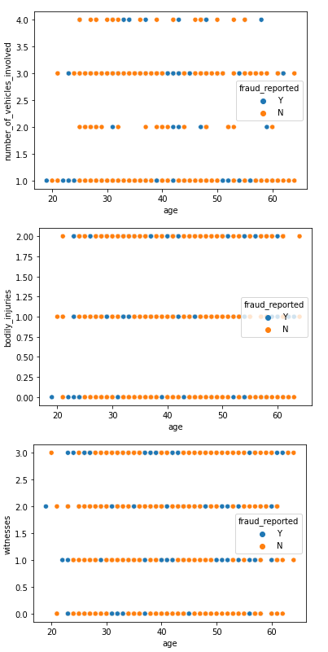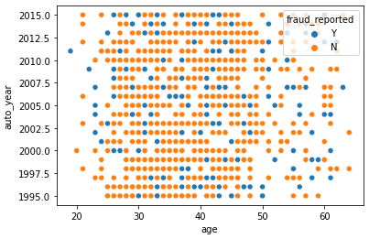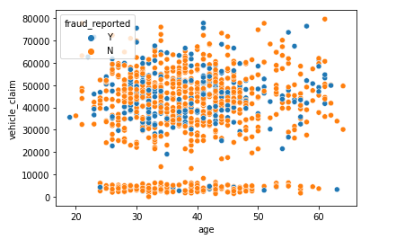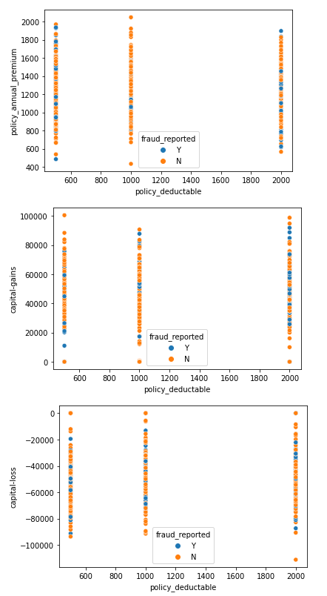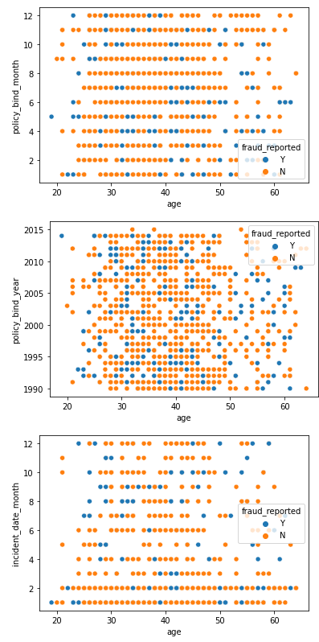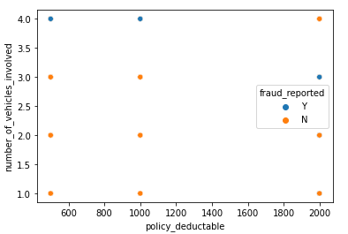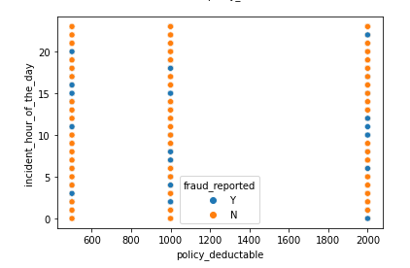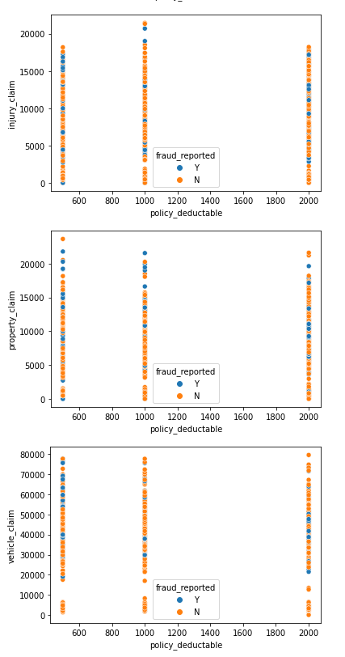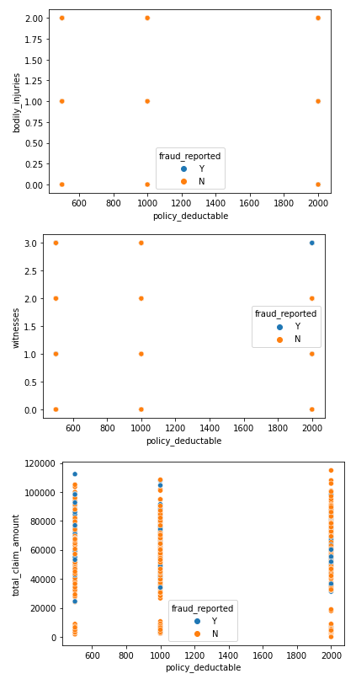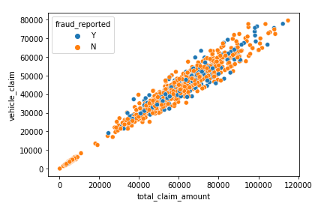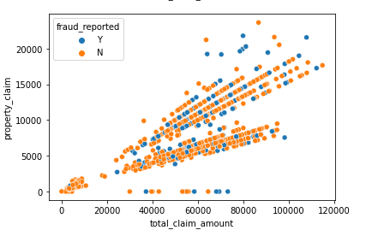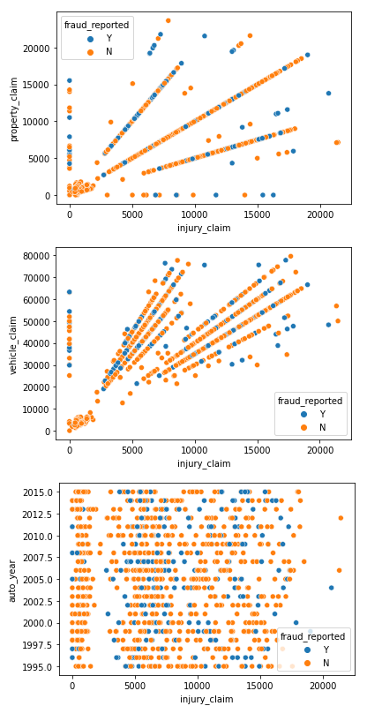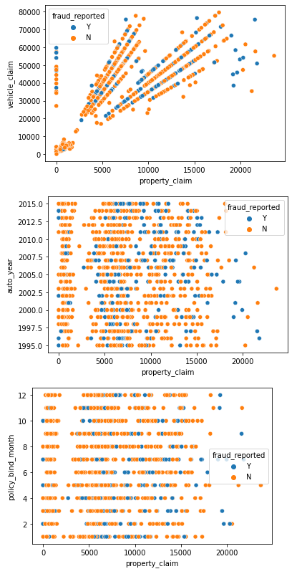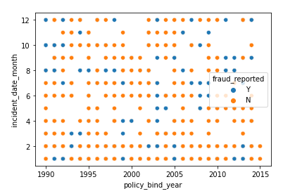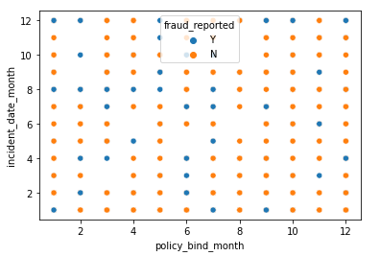

**Observations**:

1. Inquiry_claim with total_claim_amount show linear increment accordingly.
2. Similarily property_claim and vehicle claim shows also linear increment ac- cording.
3. Vehicle_claim and property_claim shows linearly increament with respect to each other.
4. Age and month as customer are directly proportional to each others.
5. Rest graphs not shows liable details.

**Violin Plot**

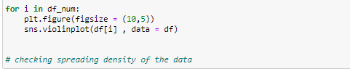

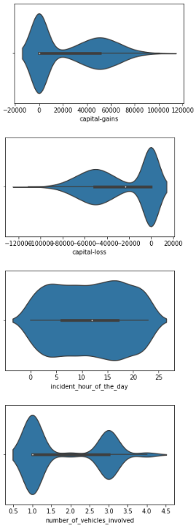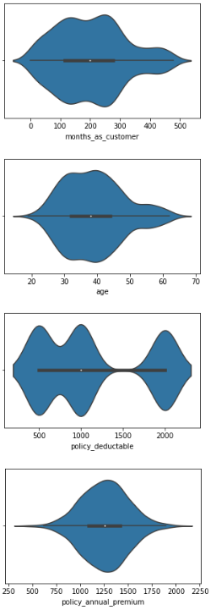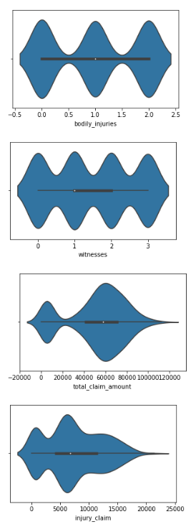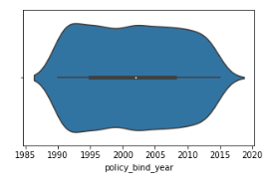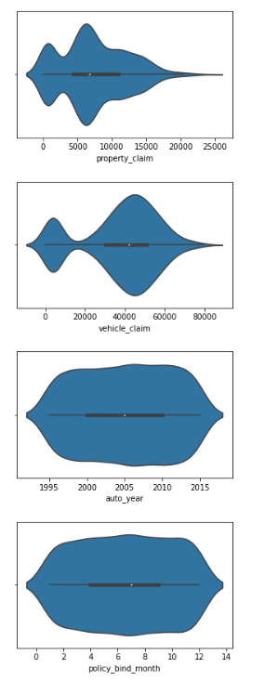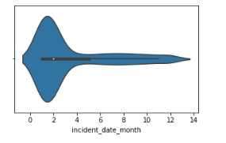

**Observations:**

1. month_as_customer having density in the range of 0 to 500 but most of the customer lies in the range of 0 to 300 approx as per graph.
2. Age having density in the range of 20 to 70 but most of the customer lies in the range of 20 to 55 approx as per graph.
3. policy_deductable are divided into 3 parts of density with different different range as per above graph.
4. policy_annual_premium its density range lies between 250 to 2000 approx.
5. capital-gains As per graph most of the people didn't get any gains but a few people gains with the range of 20000 to 100000 approx.
6. capital-loss As per graph most of the people didn't get any loss but a few people loss with the range of -20000 to 600000 approx.
7. incident_hour_of the day shows common density pattern.
8. numbers of vehicle involved it is divided into two parts which are 1 and 3 as per graph.
9. bodily_injuries it is divided into three parts which are 0 to 2 approx as per graph.
10. witness it is divided into four parts which are 0 to 3 approx as per graph.
11. total_claim_amount most of the people claim amount lies in the density ranges of 20000 to 1000000 as per graph.
12. injury_claim most of the people claim amount lies in the density ranges of 0 to 20000 as per graph.
13. property_claim most of the people claim amount lies in the density ranges of 0 to 20000 as per graph.
14. vehicle_claim most of the claim amount lies in the range of 20000 to 80000.
15. auto_year, policy_bind_month and policy_bind_year show normal density ranges as per graph.
16. incident date month most of the incident lies in January to February as per density curve.

**Checking Distribution of the Dataset**

**Distribution Plot**

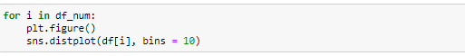

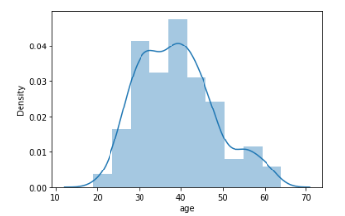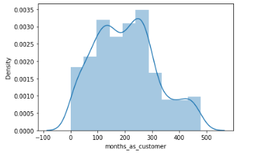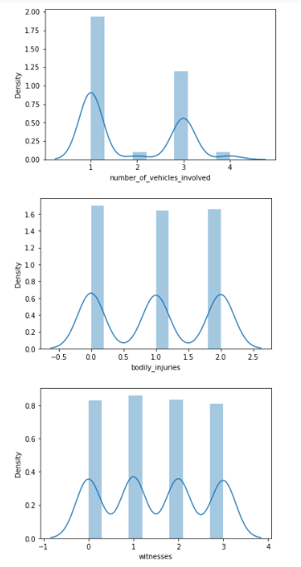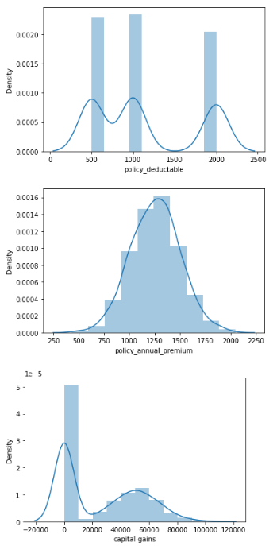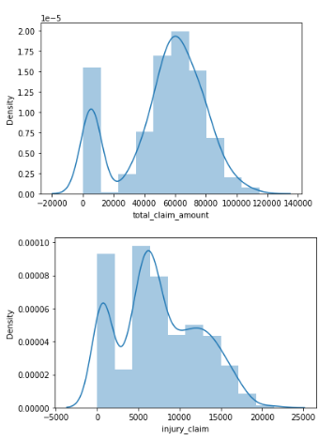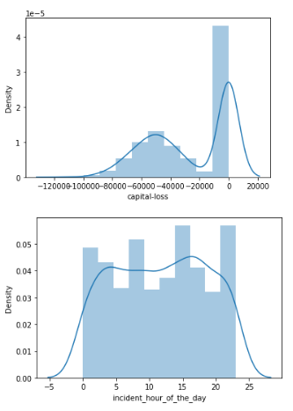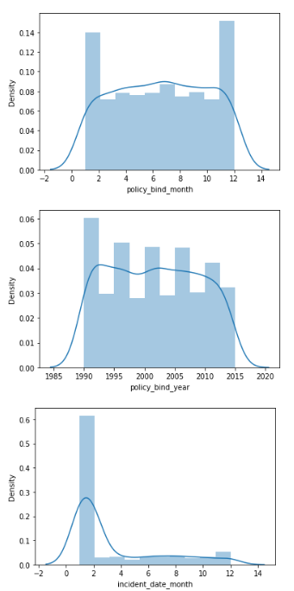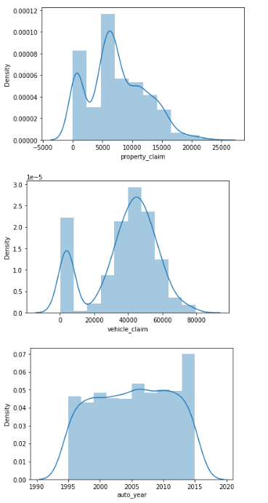

#### Observations: Distribution plot behave same as density plot with bins.

### Checking Outliers

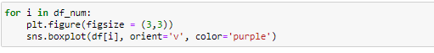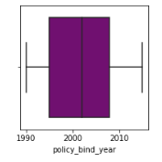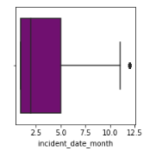

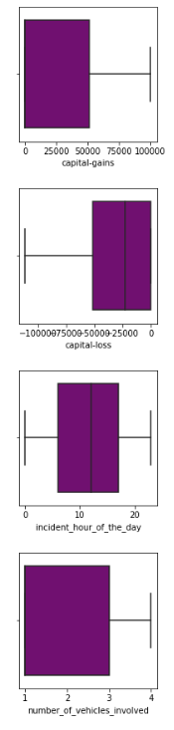

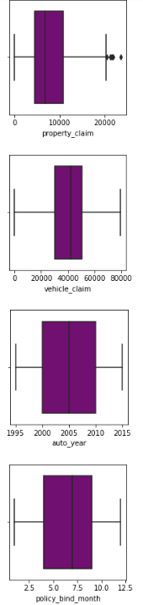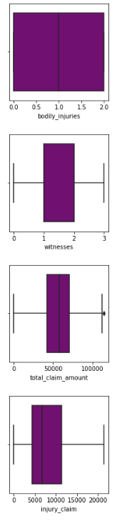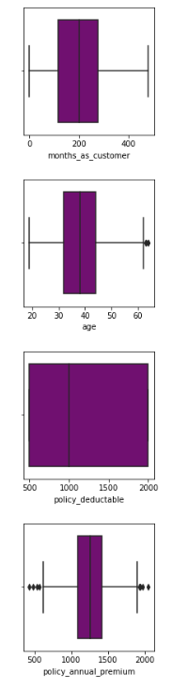

**Observations:**

1. age: age column dataset having a neglible amount of outliers as per above graph.
2. policy_annual_premimum having outliers in both criteria with fraud reported yes and no.
3. totol _claim_amount having outliers in the dataset of fraud reported.
4. property_claim having outliers in both criteria.
5. incident_date_month having outliers only in the dataset of a single month.

**Checking Skewness**

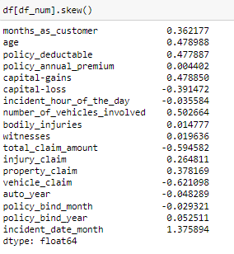

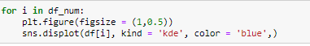

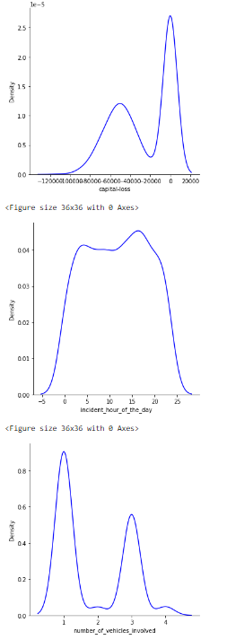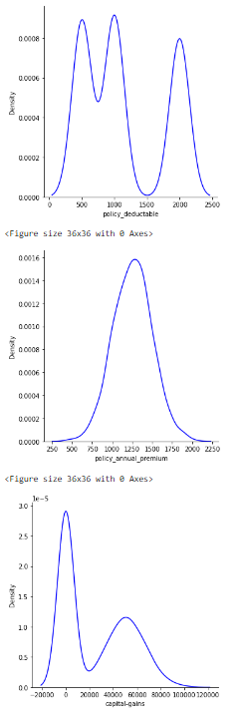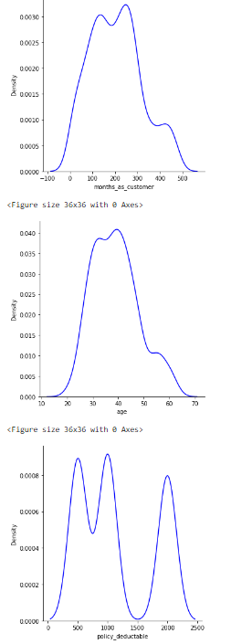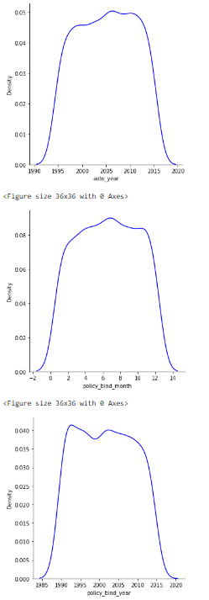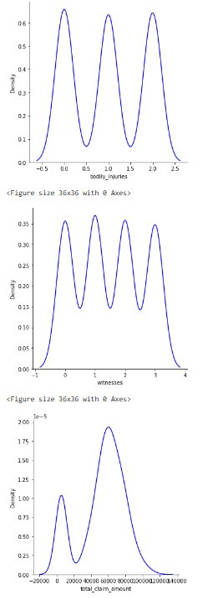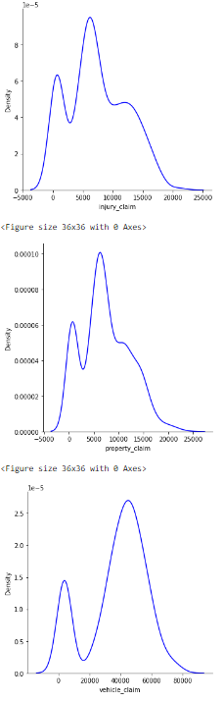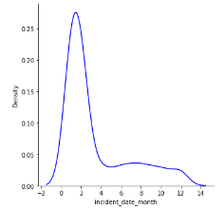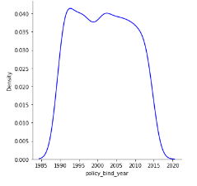

**Observations:**

Month as customer, age, policy_deductable, capital gains , number of vehicle involved, injury claim, property claim and incident date month shows right skewness towards the dataset rest of incident hour of the day, capital loss, total claim amount vehicle claim, auto year, policy bind month show left skewness towards the dataset.

**Checking Overall of the Dataset by Pair Plot**

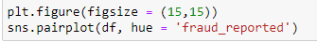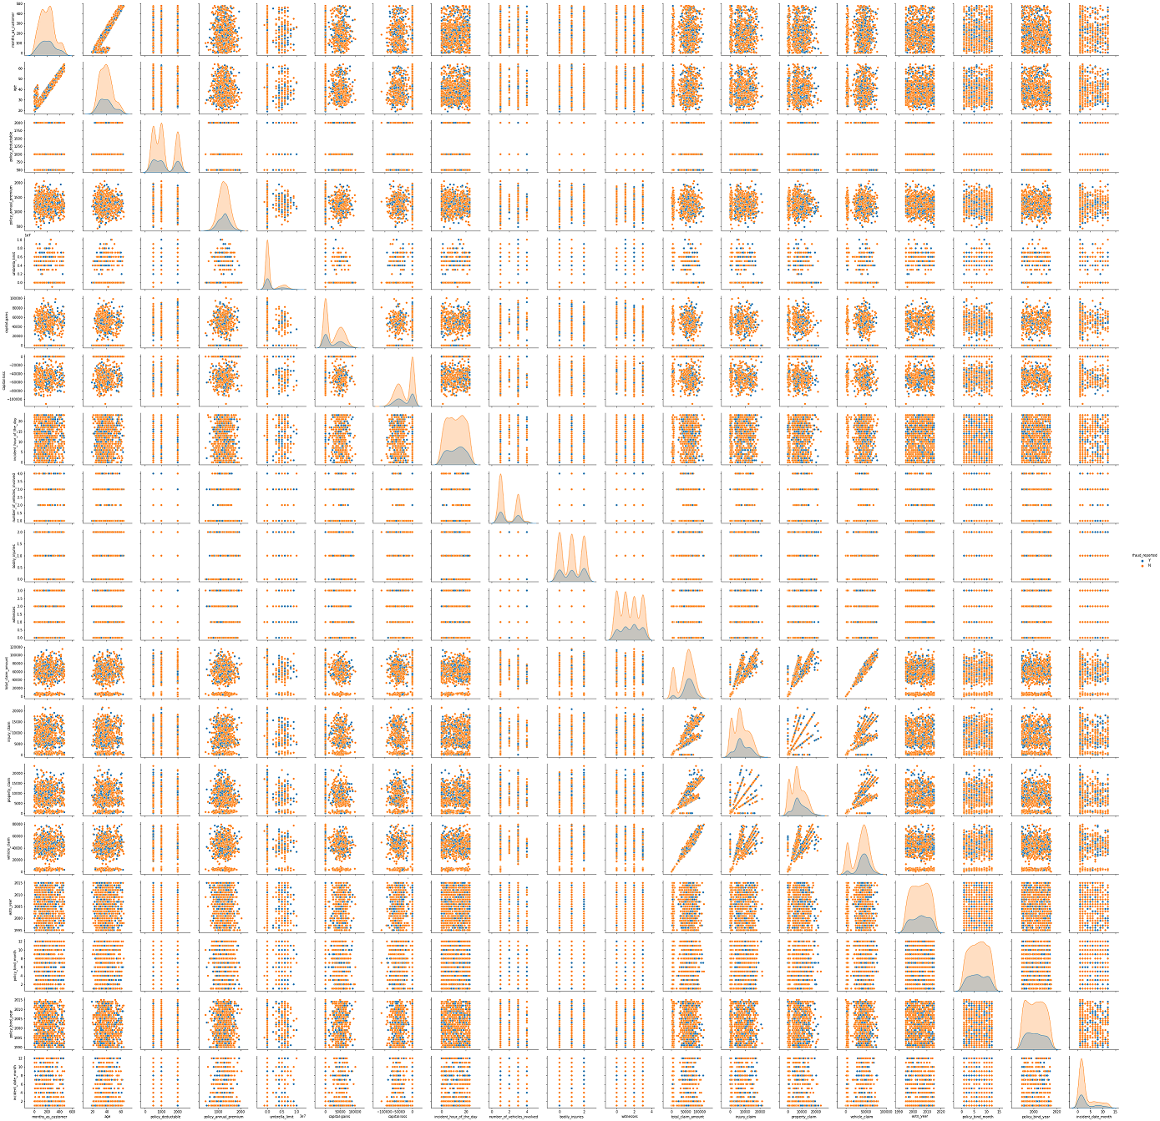

**Observations:** Measured all analysis above are similar to pair plot.

**Pre- Processing Pipelines**

**Label Encoder for target variable**

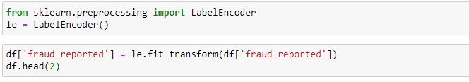

**For making similar predictor variable we are using Ordinal Encoder**

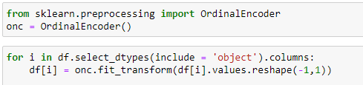

**Removing Outliers from the Dataset**

1. **Z score Method**

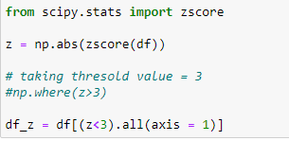

1. Interquartile Method

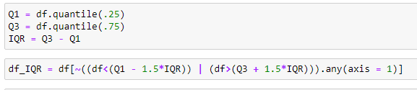

From above two methods of removing outliers we find that Z score give lesser data loss with respect to inter quartile method hence we are selecting Z score method for removing outliers.

**Describe**



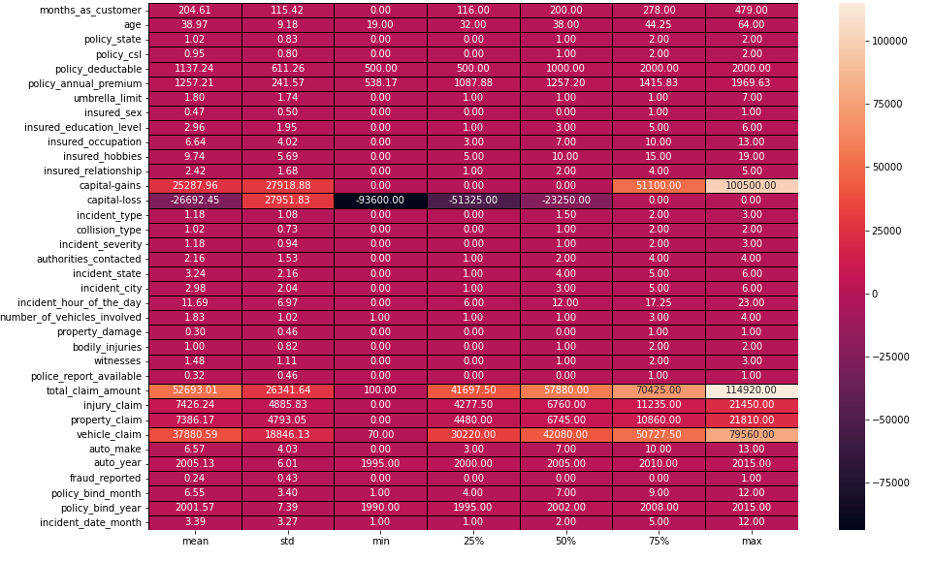

From above code we find that total claim amount , vehicle claim, capital gains values are much higher than its dataset value from this we conclude that this column dataset probably having outliers.

### Checking Correlation of the Dataset

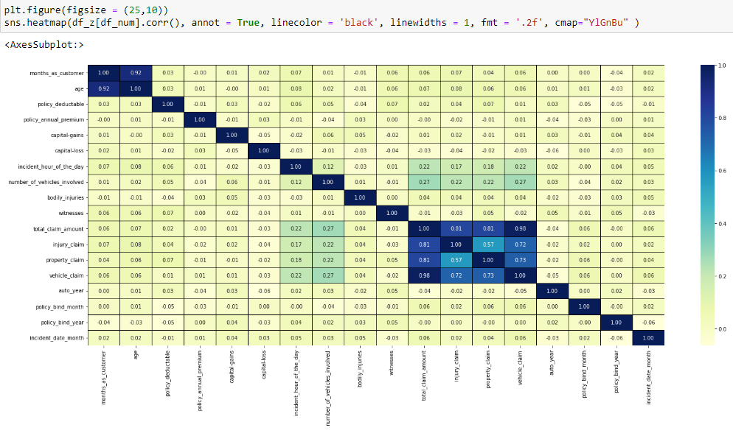

**Observations**: total claim amount, injury claim, property claim and vehicle claim shows very high correlation with each other as per graph.

## Checking Positive and Negative Correlation

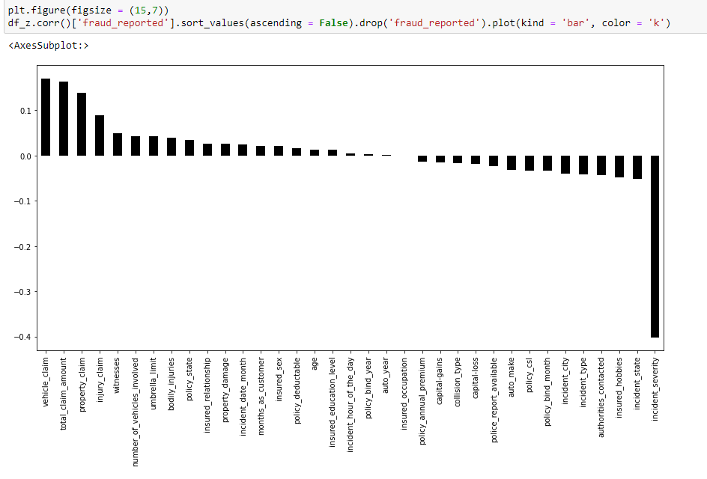

#### Observations:

'vehicle_claim', 'total_claim_amount','property_claim', 'injury_claim', 'witnesses', 'umbrella_limit', 'number_of_vehicles_involved', 'bodily_injuries', 'policy_state', 'insured_relationship', 'property_damage', 'incident_date_month','months_as_customer', 'insured_sex', 'policy_deductable', 'age', 'insured_education_level', 'incident_hour_of_the_day', 'policy_bind_year', 'auto_year' **shows positive correlation with respect to fraud reported** while rest of dataset shows **negative correlation.**

## Dividing data for feature selection

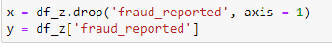

### Using Get Dummies Method to prevent overfitting of Model as Model having so many columns with Multiple Unique Values

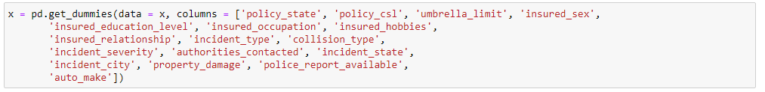

## Removing Skewness

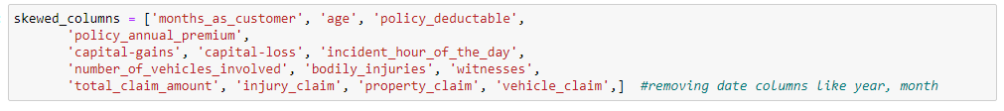

### Using Power Transformer method to remove skewness





**Checking Mutlicollinearity**

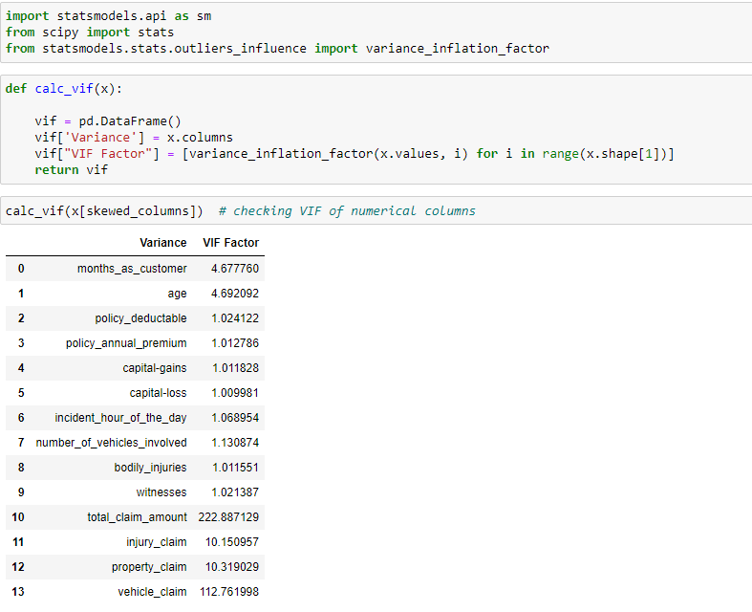

### As we can see that total claim amount and vehicle claim show very high vif hence we need to drop it. But due to less number of dataset we are dropping it one by one after checking observations.

In [117]:



## Using SMOTE to balance the dataset

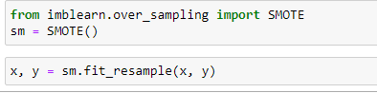

**Standard Scalling**

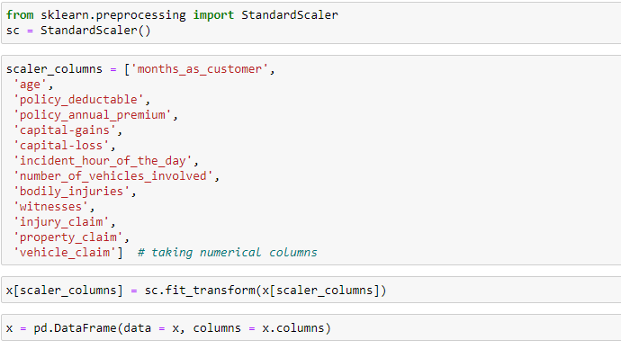

**Building Machine Learnings Models**

* **Split the data into train and test**

Both the dependent variable and independent variable was split into train and test data (70% train and 30% test)

* Four different types of model classifiers were used in this project for finding best accuracy score:

- Logistics Regression

- GaussianNB

- Support Vector Classifier

- AdaBoostClassifier

## Model 1 Logistics Regression

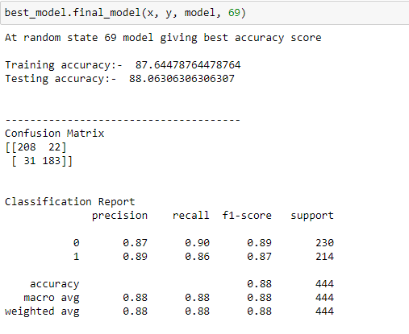

**Model 2 GaussianNB**

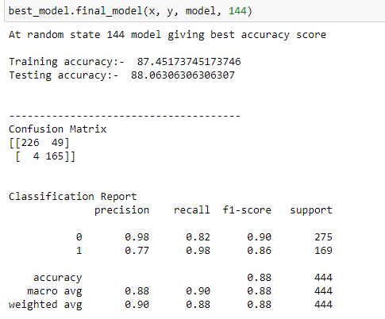

## Model 3 Support Vector Classifier

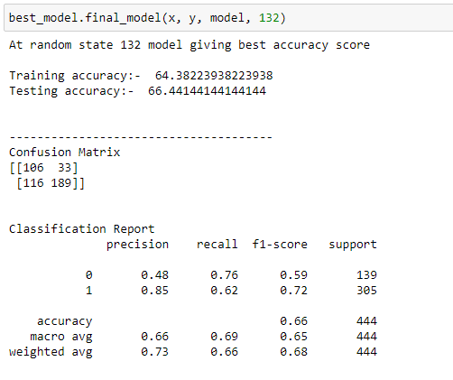

## Model 4 AdaBoostClassifier

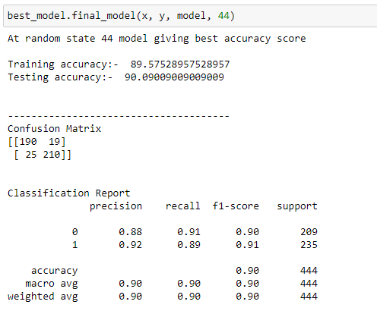

**Cross validation score of each of the algorithm:**

|  |  |
| --- | --- |
| LogisticRegression | 86.08108108108108 |
| GaussianNB | 85.17697298185102 |
| SupportVectorClassifier | 57.56756756756756 |
| AdaboostClassifier | 86.51350907448467 |

### Observations:-

* LogisticRegression: Model shows similar training and testing accuracy but accuracy score is very less than other models hence we can't consider it for model building.
* GassianNB: Model shows similar training and testing accuracy but accuracy score is very less hence we can't consider it for model building.
* SupportVectorClassifier: Model shows similar training and testing accuracy but accuracy score is very less hence we can't consider it for model building.
* AdaboostClassifier: Model show higher accuracy also having less difference in accuracy of testing and training. Hence we can't consider it.

### From above Machine Learning Models we find that AdaBoostClassifer show highest accuracy with rangeable cv score with lower differences in accuracy score.

Ensemble Technique

## Hyper Parameter Tuning

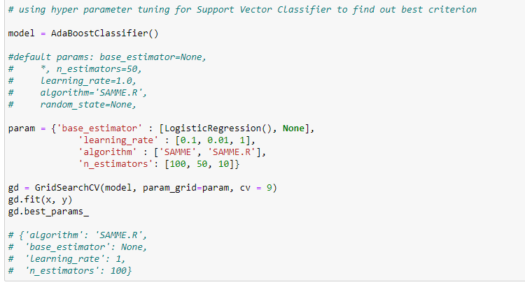

**Final Model AdaBoostClassifier**

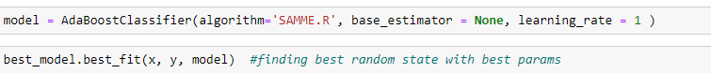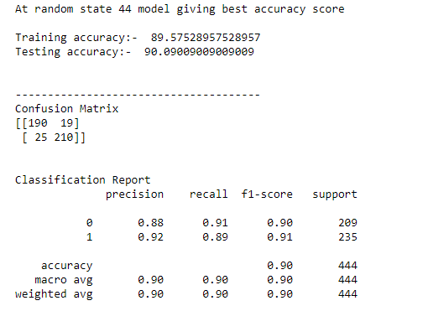

**AOC – ROC Curve**

### Using Predict Proba function for finding accuracy target variable



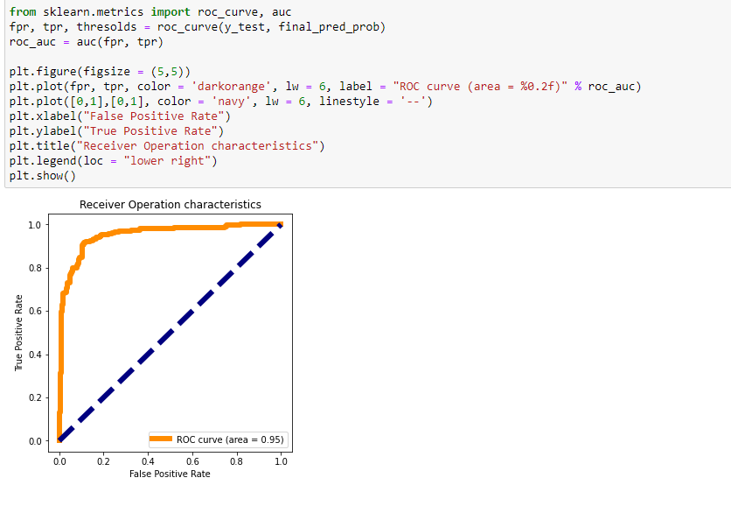

### Deploy Model

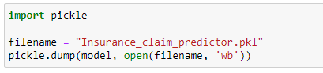

### Loading Model

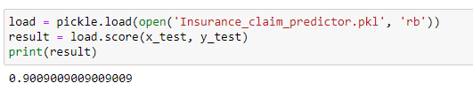

**CONCLUDING REMARKS**

### This project has built a model that can detect auto insurance fraudulent customers via customer data. Because these days investigating a single case being very time consuming also it becomes very complex to identifying a whole number of fraudulent.

### To identifying fraudulent through dataset will be very grateful to the industry specific.

### Four different classifiers were used in this project as above mention but the best model for the dataset chosen is AdaBoostClassifier model.

### The Model can predict with an accuracy of 90.09 %, that, the customer is fraudulent or not

### Conclusion

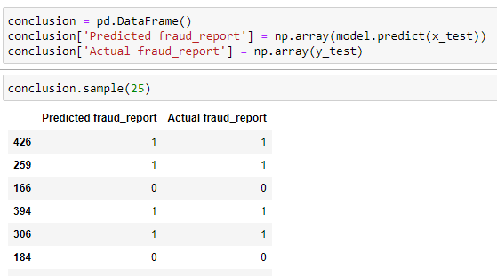

**Github link:**

<https://github.com/arjun0200/Evaluation_Projects/blob/main/Insurance_Claim_Fraud_Detection.ipynb>

<https://github.com/arjun0200/Evaluation_Projects/blob/main/Insurance_Claim_Fraud_Detection_final.ipynb>